KEMPTVILLE NEWSLETTER  APRIL 2026 |  |   FAITH BAPTIST CHURCH  Pastor: Reverend Edward Burrill  Location: 349 North Kemptville Road  Telephone: 1-902-354-7390  Sundays  Worship Service – 2:00 pm  ***  KEMPTVILLE UNITED BAPTIST CHURCH  Pastor: Reverend Kevin Jamieson  Location: 16 North Kemptville Road  Email: kemptvilleubchurch@gmail.com  Telephone: Church - 902-761-2050  Residence - 902-761-2424  Facebook: @kemptubchurch  Sundays  Worship Service – 11:00 am  Wednesdays  Prayer Meeting – 7:00 pm  GOOD FRIDAY SERVICE  A Good Friday Service will be held at the Argyle-Pubnico Baptist Church, located at 4554 Highway 3, Argyle, 2:00 pm, April 3.  UBC YOUTH MEETINGS  The Kemptville Fusion Junior Youth Group meetings
  HAPPY EASTER
  
  APRIL 5, 2026
 |  | 2
are held on Tuesday evenings from 6:00 pm – 7:30 pm. This group is for elementary school aged children.  The Kemptville Fusion Youth Group meetings occur on Thursdays, from 6:30 – 8:00 pm. This group is for junior and senior high aged youth.  Join us for games, snacks, Bible lesson, and so much more at the Kemptville United Baptist Church. A canteen exists, with all items $3.00 or less.  Follow us on Facebook: Kempt Fusion Youth. For more information, contact Emma Surette at 902-740-7475 or emma.surette123@gmail.com.  SENIORS’ AFTERNOON  A Seniors’ Afternoon is scheduled for Monday, April 27, from 1:30 – 4:00 pm. All seniors are welcome to attend.  FOOD BANK  Non-perishable donations may be dropped off for the Food Bank at the church or arrangements made to have items picked up. Contact Carolyn Foote, 902-749-7464, or Marge Parker, 902-761-2269, for more infor-mation.  ***  VICTORY BAPTIST CHURCH  Pastor: Reverend Joey Ring  Location: 1920 Highway 203, Kemptville  Telephone : Church – 902-761-2562  Sundays  Sunday School – 10:00 am  Morning Service – 11:00 am  Evening Service – 6:00 pm |  | Wednesdays  Evening Service – 7:30 pm  ***  !! HAPPY BIRTHDAY !!    Happy Birthday to the following individuals who are celebrating a birthday during the month of April:  !! HAPPY ANNIVERSARY !!  Happy Anniversary to the following couples who are celebrating an anniversary during the month of April:  If the names of any individuals living within our com-munity are missing from the above lists, please provide details as outlined on the last page of the Newsletter.  ***  KEMPTVILLE DISTRICT  VOLUNTEER FIRE DEPARTMENT    KDVFD MONTHLY MEETING  The Firefighters’ Monthly Meeting will be held April 7, 2026, at 7:00 pm.
  04 – Kevin Roberts | 23 – Matthew Crowell
  08 – Kerry Crowell | 28 – Deacon Crowell
  08 – Jeremy Roberts | 29 – Judy Roberts
  18 – Greg Robb | 30 – Jeff Gates
  22 – Susan Baron
  12 – Greg & Barb Robb | 26 – David & Joanne Hanley
3 |  | 4
KDVFD MONTHLY TRAINING SESSION  The Firefighters’ Monthly Training Session will be held April 14, at 7:00 pm.  SUPPORT KDVFD THROUGH  RAFFLEBOX  If you would like to support the KDVFD, you can do so by purchasing 50/50 tickets at rafflebox.ca/raffle/nsfd. Be sure to select the Kemptville Volunteer Fire Department as the department you wish to support when purchasing tickets.  NEW VOLUNTEERS  Any resident interested in joining the KDVFD is to contact Chief Bruce Gates at 902-761-2683.  ***  COMMUNITY POTLUCK BREAKFAST    The next monthly community potluck breakfast is scheduled for April 4, 2026, starting 10:00 am, at the United Baptist Church vestry. All residents are welcome to attend!  For further information, contact Barb Robb at 902-761-3460 or Robert Zwicker at 902-761-2274.  ***  KEMPTVILLE LADIES’ AUXILIARY  ANNUAL GENERAL MEETING  The Kemptville Ladies’ Auxiliary will be holding its |  | Annual General Meeting on Monday, May 4, 7:00 pm, at the Fire Hall.  There will be an election to fill vacancies for President and Secretary. If anyone wishes to be considered for these positions, please send an e-mail to the Nominating Committee at rdemolitor@bellaliant.net or rdemolitor5@gmail.com. Please include your name and phone number, along with a short explanation as to which position you would consider and why. Deadline for sub-mission is April 24, 2026.  ***    LAKEVIEW CEMETERY - MAINTENANCE  Lakeview Cemetery, located behind the United Baptist Church at “Kempt Corner”, is looking for someone to mow and whipper-snip this summer. Mower, whipper-snipper, and gas are provided. If interested, please contact Justin Gray at 902-761-2966 or Kendrick or Carolyn Mood at 902-761-2184.  ***  HATFIELD MEMORIAL CEMETERY  ANNUAL GENERAL MEETING  Hatfield Memorial Cemetery will hold its Annual General Meeting on Saturday, April 11, 2026, 7:00 pm, at 3012 Highway 203, East Kemptville. All lot holders welcome.  ***
5 |  | 6
*** |  | EAST KEMPTVILLE MEETING HOUSE SOCIETY  ANNUAL GENERAL MEETING  The East Kemptville Meeting House Society will hold its Annual General Meeting on Saturday, May 2, 2026, 7:00 pm, at 3012 Highway 203, East Kemptville. All members are encouraged to attend.  ***  KDVFD RATE PAYERS’ MEETING  At the Rate Payers’ Meeting held by the KDVFD on March 3, a proposal to implement an Area Rate of $.05 per hundred dollars ($0.05/$100) of assessed property value was passed. These funds are being used to assist in the purchase of a fire truck to replace Engine 1. This area rate will remain in place for a six-year period unless the truck is paid off sooner.  The proposed budget for operating the Fire Department during Fiscal Year 2026/2027 was not available at the Rate Payers’ Meeting or prior printing the Newsletter.  ***  KEMPTVILLE BETTERMENT SOCIETY    ANNUAL GENERAL MEETING  The Kemptville Betterment Society will hold its Annual General Meeting (AGM) on Monday, April 27, 2026, 7:30 pm, at the United Baptist Church vestry. All members and other interested persons residing in Kemptville are welcome to attend.
  YARMOUTH GARDEN CLUB
  
  MAY PLANT SALE
  Thursday, May 14, 2026
  NSCC Burridge Campus
  Gymnasium Entrance
  372 Pleasant Street
  Yarmouth
  5:00 to 7:00 PM
  Please bring your own tote / box.
  Many varieties of perennials such as, ornamental
  grasses, lilies, hostas, ground covers, astilbes,
  Susans, phlox, irises, shrubs, bushes, vegetables,
  house plants and MUCH MORE.
  ADMISSION $ 3.00
  THERE WILL BE DOOR PRIZES
  We’ll gladly take plant donations from anyone
  who has extra up to May 13.
  Please contact christina.lennox79@gmail.com.
  New members are always welcome!
7 |  | 8
KEMPT DAY - SAVE THE DATE!  The Kemptville Betterment Society will be hosting Kempt Day on Saturday, July 11, from 11 am to 3 pm at the Kemptville Fire Hall. This event will provide an opportunity to bring our community together to enjoy a day of food, fun, games and music for everyone. Funds raised will be used to support KBS community projects.  Watch for additional details on Kempt Day in coming issues of the Newsletter. For questions or comments, contact Robert Zwicker at kemptville200ns@gmail.com. Save the date on your calendar!  BAKE SALE TO SUPPORT KEMPT DAY CELEBRATION  The Kemptville Betterment Society will be holding a Bake Sale at the Yarmouth Mall on Thursday, April 30, beginning at 9:30 am. All proceeds will be used to support the Kempt Day event on July 11 and other KBS community initiatives.  Anyone interested in supporting this event by baking goods is to contact Barb Robb at 902-761-3460 for further details. See you at the Bake Sale!  LAKEVIEW GARDEN - UPDATE  In the January, 2026, edition of the Kemptville Newsletter, KBS published an article relating to the history of the triangle-shaped garden located by the United Baptist Church (UBC), named Lakeview Garden. Residents were asked to contribute any additional information they had relating to the garden. Much of what has been received enhances the content of the previous article. We wish to thank Carolyn Mood and Harold Crowell for the |  | recent information and photographs.  According to Carolyn, work began on the garden on, or about, April 13, 1971, by the United Baptist Youth Group, of which she was a member and a participant in this project.  By June the garden was ready and flowers were planted June 15, 1971. At least some work on the garden was completed by the Youth Group in June of 1972.  The following picture of the United Baptist Youth Group was taken across from the church on the North Kemptville Road, Saturday, April 24,1971. A 14-mile walk-a-thon to Carleton was held that day to raise money in support of the garden. If you can identify the two unknown individuals, please pass the names along to us.  In the back row, left to right: Judy Hanley, Billy Gates,  Ann Cochran, Bruce Beveridge, Bruce Cochran, Miriam Roberts,  Carolyn Greene, Donna Whitehouse, Rev. Owen Cochran.  Front row, left to right: Unknown, Curtis Randall, Wendy Mood,  Karl Cochran, Judy Roberts, Mark Gates, Unknown, Lawrence Roberts. (Picture and names provided by Carolyn Mood.)
9 |  | 10
The following was also kindly provided by Carolyn: The garden was started in 1971 when Reverend Owen Cochrane was the minister of the United Baptist Church (UBC). The garden was a project undertaken by the youth group of the UBC, with Wendy Mood being one of the members. When Wendy passed in June 1976, a plaque in her memory was placed on a tree in the garden by the local chapter of the Women’s Institute of Nova Scotia (WINS). The tree eventually rotted and the plaque was moved to the UBC. The whereabouts of the plaque is now unknown. The garden did not exist very long before the Women’s Institute took over its care. The rock wall likely did not exist initially; instead, it is believed that Phyllis Hoyle-Mood created the rock wall later.  The picture below is of an engraved brass plaque, approximately 9 X 11 inches, once attached to a tree in Lakeview Garden.  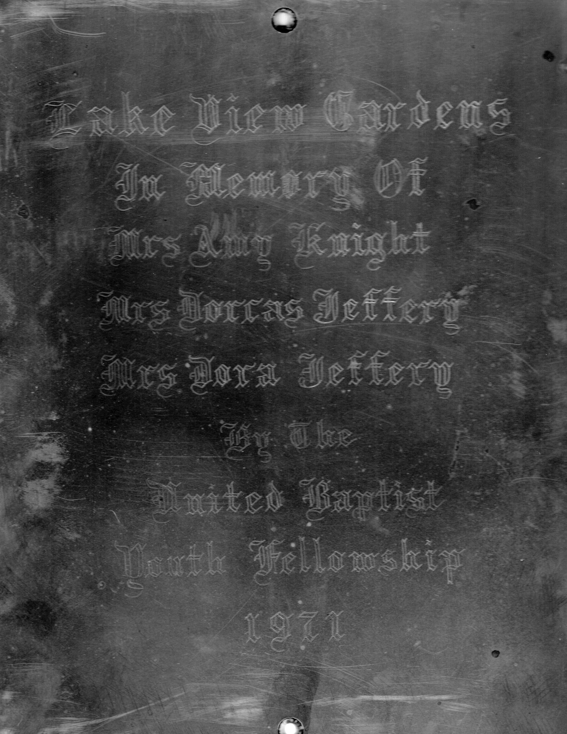 |  | Although difficult to read, the plaque reflects:  When the tree rotted, the plaque was saved. We have Harold Crowell to thank for finding this plaque - another piece of Kemptville history.  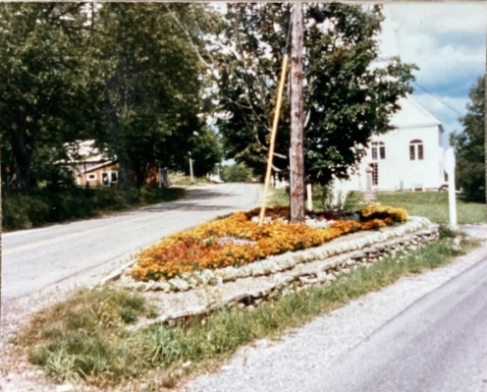  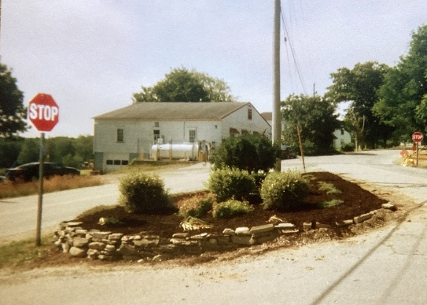
  Lake View Gardens
  In Memory Of
  Mrs Amy Knight
  Mrs Dorcas Jeffery
  Mrs Dora Jeffery
  By The
  United Baptist
  Youth Fellowship
  1971
11 |  | 12
These two pictures were supplied by Harold Crowell. One photo has “Lakeview Garden” written on the back. The date of these photos is unknown but they were obviously taken at different times.  Thanks again to Carolyn and Harold for sharing these photographs and additional information!  ***  GENERAL NEWS  AMENDMENTS TO  PROVINCIAL ELECTORAL PROCESS  Amendments to the Elections Act and House of Assembly Act were introduced on February 26, 2026, with the objective of modernizing Nova Scotia’s electoral process.  Most amendments were recommended by Nova Scotia’s Chief Electoral Officer following the 2021 and 2024 provincial elections. The Chief Electoral Officer is the head of Elections Nova Scotia, and is an independent, non-partisan agency responsible for administering the Elections Act.  Amendments include:  - removing the requirement for returning officers to reside in the electoral district in which they were appointed;  - removing the requirement for candidates to pay a $200 nomination deposit;  - clarifying rules on the transfer of services, money or property among related entities to cover situations that arise when a candidate later runs as an independent or for a different registered party;  - allowing candidates to pay for publicity costs directly |  | and with their personal credit card;  - limiting an official agent to represent a maximum of one candidate per electoral district;  - changing the term for the chair of the Election Commission to account for a change in government;  - requiring a returning officer to provide, upon request by a candidate, candidate’s representative or registered party, an electronic record identifying every elector who, the previous day, had been crossed off the list of electors as having voted or declined to vote or been added; and  - clarifying that the Register of Electors may be used by a registered party, member of a registered party, registered candidate or member of the House of Assembly for the purpose of communicating with the electors, including the soliciting of contributions, campaigning and recruiting party members.  LOWER BANK FEES  Effective March 12, 2026, new regulations came into effect for federally regulated banks within Canada.  The following outlines the primary changes:  - consumers cannot be charged more than $10 for non-sufficient fund (NSF) fees when sufficient money does not exist in a personal deposit account to cover a payment;  - consumers will not be charged an NSF fee more than once in a period of two business days for the same personal deposit account; and  - consumers will not be charged NSF fees on a personal deposit account when the amount of
13 |  | 14
their overdraft on that account is less than $10.  Before these new NSF regulations came into force, NSF fees typically ranged from $45 to $48. These fees were often applied regardless of the size of the shortfall and could be charged in succession because of multiple declined payments. These changes are expected to save Canadians more than $600 million annually.  The Financial Consumer Agency of Canada (FCAC) is responsible for supervising the compliance of federally regulated financial entities and will oversee industry compliance with the new NSF fees.  Fourteen federally regulated financial institutions, including Canada’s six largest banks, have signed on to a modernized Commitment on Low-Cost and No-Cost Accounts. Since December 1, 2025, Canadians have benefitted from no-cost and low-cost accounts costing no more than $4 per month.  FEES TO SWITCH INTERNET AND CELLPHONE  PLANS TO BE ELIMINATED  The CRTC recently announced that it is removing fees that make it more difficult for Canadians to change or cancel Internet and cellphone plans. This change is to take effect on June 12.  Changes to the Telecommunications Act require that CRTC put new consumer protection measurers in place. As part of this work, the CRTC held public consultation to better understand how fees can prevent Canadians from switching plans. A wide range of perspectives was heard from individuals, consumer groups, and service providers.  Based on the public record, the CRTC is eliminating |  | extra fees to activate, change, or cancel a plan. This will provide consumers more flexibility to manage their plans and take advantage of better offers without worrying about unexpected costs.  In the coming months, the CRTC will make it easier for consumers to shop for, compare, and choose the plans that are best for them. A review of consumer protection codes will also be undertaken with the goal of simplifying and combining them into one code. More information is available at CRTC’s Consumer Protections Action Plan on the Internet.  PROTECT YOURSELF FROM FRAUD  March was Fraud Prevention Month. The Canada Border Services Agency (CBSA) is therefore warning Canadians about scammers who pretend to be CBSA officials.  There are many sophisticated frauds and scams in Canada. Some attempt to imitate federal government services to gain access to personal and financial infor-mation. The methods and messages used by scammers are always evolving. In some cases, telephone calls may display numbers and employee names that falsely appear to be from the CBSA. Emails may contain official logos, email addresses or employee names and titles to mislead the public.  The following are tips from CBSA to help you recognize, report and protect yourself from fraud:  - The CBSA never contacts individuals by email, web, text message or telephone to ask for payment or personal information.  - The CBSA never initiates a request for a Social
15 |  | 16
Insurance Number (SIN) or a credit card number by telephone, text, or e-mail.  - If this happens, ignore, hang up or don’t answer the text or e-mail and report the incident to the Canadian Anti-Fraud Centre (CAFC).  If you receive a call telling you that you must pay duties and taxes on a package that the CBSA is holding and threatens penalties, including jail time, it is a scam.  CBSA may call recipients / importers to clarify package declaration details; however, it is Canada Post that is responsible for collecting duties and taxes prior to a mail  item being delivered to the recipient, not CBSA.  If you have a package coming to you via courier shipment (FedEx, UPS, etc), the courier company will reach out to you to organize the duties and taxes payment prior to the delivery. The courier, not CBSA, will hold the package until your payment is made.  If you have been a victim of fraud or cybercrime, you need to contact your local police as soon as possible. It is the role of your local police to investigate these crimes. It is recommended that you also report any instance of fraud or cybercrime, whether you are a victim or not, to the CAFC. The CAFC assists law enforcement through maintaining a central repository of information to assist with investigations.  You can report a fraud or cybercrime online at reportcyberandfraud.canada.ca. You have the choice to report anonymously if you wish. Reports can also be made by telephone, toll free, at 1-888-495-8501, Monday – Friday, 10 am – 4:45 pm Eastern time.  The CAFC supports law enforcement by sharing |  | information collected through the reports from victims by:  - working with the National Cybercrime Coordination Centre;  - linking a number of crimes together, in Canada or abroad;  - assisting in progressing or completing an investi-gation;  - developing crime trends and crime forecasting; and  - assisting with crime prevention and awareness efforts.  ***  HEALTH AND SAFETY  LONG-TERM CARE FACILITIES –  CUPE AND NS GOVERNMENT NEGOTIATIONS  As of March 20, no agreement has been reached between CUPE and the Nova Scotia government relating to employees at more than 50 long-term care sites.  The latest information indicates 23 non-CUPE groups have accepted an offer that was rejected by CUPE. The final day for conciliation is scheduled for March 24. If a deal is not reached, the union would be in a legal strike position 48 hours later.  Impacted workers include continuing care assistants; licensed practical nurses; support services which includes environmental, housekeeping and laundry; occupational therapy aids and physiotherapy aids; and maintenance. The contract for these CUPE members expired in October 2023.  Essential service agreements are in place to ensure nursing home residents continue to receive needed
17 |  | 18
services should a strike occur.  NEW FIRE PROTECTION SERVICE LEGISLATION  As referenced in the November 2025 Newsletter, the Nova Scotia government introduced the Support for Fire Protection Services Act on February 23, 2026.  Under this act, the Minister for Emergency Manage-ment will provide oversight for municipal fire services and set provincewide standards for fire services, firefighter training and certification, personal protective equipment, transition support for fire services that want to transition to a municipal model, and resources for fire protection services planning, delivery and reporting.  Fire Departments and fire service commissions that are not currently part of a municipal fire service will remain as is.  This act enables the creation of an Office of the Fire Commissioner, the first step in providing provincial oversight, coordination and support to municipalities and fire service providers.  It requires all municipalities, whether they oversee fire services or not, to:  - conduct a fire protection service review, to ensure municipalities and fire departments make evidence-based decisions about the services they provide to their community;  - ensure that local firefighter competencies, training and personal protective equipment meet the service standard required by the fire protection service review; and  - participate in a common records management |  | system.  The bill allows for improvements in mental health support for firefighters, volunteer recruitment and retention, training and interoperability and mutual aid.  The legislation is part of the Province’s ongoing commitment to strengthening the fire services sector. It will help ensure consistent training standards across the province and support procurement to get best pricing for purchasing vehicles, equipment and insurance, helping fire departments reduce costs.  The province consulted with more than 700 partici-pants, including municipal elected officials and adminis-trators, fire service leaders, firefighters, fire commissions and fire service co-ordinators.  There are currently 363 fire service organizations in the province, with varying levels of service. More than half of all municipalities already provide fire protection services directly to Nova Scotians.  FIRE RESTRICTIONS  Wildfire season officially began in Nova Scotia on March 15 and will last until October 15. Daily burn restrictions are now in place that require residents to check conditions before burning. Daily updates are posted at 2 pm.  The Department of Natural Resources Forest Protection section has indicated that winter snow and rain has helped to offset the dry conditions that developed throughout Nova Scotia last year.  Spring, however, is a high-risk wildfire period. The time between when the snow disappears until vegetation
19 |  | 20
begins to turn green in late May or early June, increased potential for fires exists. The dry grass and snow-free ground increase the potential for fires.  Fixed-wing water bombers have been contracted and will be stationed in Nova Scotia from May through September. These aircraft will supplement the existing helicopter fleet. The province has also expanded training and equipment in order to better address wildfires.  ***  DO YOU KNOW … . We continue the story of former North Kemptville resident Fannie Burrell Hatfield’s trip to Alberta starting in 1912 to visit her brother Bowman Burrell, who is referred to in Fannie’s journal as “Bom”.  Last month, Fannie hosted and attended more dances, work continued in the hay fields, and while on vacation, Ed Larsen visited Fannie and Bom.  Bom and I used to go picking saskatoons quite often. Bom was a much faster picker than I was, for I ate too many. I said I didn’t like them very well, and how the others laughed at me. They are something like blueberries, only blacker and drier, but very easy to pick. They grow on tall bushes, about three or five feet high, without brambles. A person ties his pail on a belt, then picks with both hands. We all went up on a patch near Mr. Womax’s, and we used to meet almost everybody whom we knew there. It was great fun. I preserved about 40 quarts and some of them were very good. Sometimes I went on Dick, but usually Bom used to go and take the big horses and the wagon. One day, I was going on Dick and I put a pail in a sack and tied it on the saddle horn. The instant I mounted, Dick heard the rattle of the pail and away he flew down the road towards Mr. Tate’s. It was nearly a mile before I recovered |  | by breath and got him stopped. I lost my hat in the flight  and I certainly was frightened, but no serious harm done. I made Mr. Dick come back nearly as fast as he went, and we went for saskatoons after all. I also used to go for choke-cherries on horseback. That was slow work, but the jelly was very good, so I felt rewarded.  In the fall, we began to talk of moving. The slew and the old well would both soon be dried up, and as we couldn’t live without water, we had to find another place. Bom was away so much that I threatened to trade him off for a better man or none at all. He rode down to the Battle River Creek twice and got several large pickerel. I also rode down several times and got two or three smaller fish than he caught. One day the Paull boys came out to see (4th July) and they and Bom, Russel and I went down to the Creek with the horse and wagon. It was very hot, and they only got two fish to pay for their trouble. I was too lazy to fish any, but preferred to sit in the shade of the willows.  When it came threshing time, about Sept 20th, I went down to Mrs. Gordon’s to help her with the threshers.  Thrashing combine.
21 |  | 22
There were 18 men, sometimes more, and we were quite busy at mealtimes. There were two young men there from Boston, Mass, and it seemed as if they were from home almost.  Thrashing machine [pulled by a pair of oxen].  I tried to get pictures of the crew and separator and engine, but they didn’t develop well. While there, I got my only fall from a horse. Winnie and I were riding over to her sister’s one afternoon. Our horses, Dick and Dorky, seemed eager for a race, so away we went. A small boy had helped me to saddle and neither saddle or bridle were on right. I had just leaned forward to fix the bridle when Dick shied, and I took a “high dive”, my shins scraping a fence post all the way down. Dick ran on, and I jumped up laughing. Winnie wanted to laugh but didn’t dare to, until she saw me. It was very comical and we had a big laugh about it, but it was a very narrow escape from instant death or very serious injuries. I felt quite stiff for a day or two, and one of my shins didn’t get well for several months, but that was all. We had a hard time finding and catching Dick, but made him pay for it later. |  | Friday afternoon, I went “home” or rather, to a new house which Bom had rented over at Bittern Lake. Bom had “moved” during the week, with Ralph’s help, then Ralph went back to Wetaskiwin. Bom was living in the granary because Mrs. Moon and her family were living in the house. We moved in and Mrs. Moon went over to help Mrs. Jordan, our neighbour across the road, with the threshers. I also helped, but as we only had them for five meals (22 men) we felt very pleased. Those were busy days.  (To be continued in the next Newsletter.)  NOTE: Fannie will soon start her return trip to Nova Scotia, so articles relating to her first visit to Alberta will end shortly. If anyone has other historical information relating to Kemptville that could be used in our Newsletter, please contact Robert or Lila Zwicker at 902-761-2274.  ***  Editors’ Note: Anyone wishing to have an item included in the News-  letter is to submit information no later than the 20th of the month for publication in the next edition. Items may be provided by e-mail to kemptville.newsletter@gmail.com, dropped off or mailed to 3012 Highway 203, East Kemptville, B5A 5P5. Please ensure your name and telephone number are provided with any submission. To report errors, omissions or for more information, contact either Robert or Lila Zwicker at 902-761-2274 or at the above e-mail address. An electronic version of the Newsletter is available at www.kemptville200ns.com.  ***  SUBMISSIONS FOR THE NEXT EDITION ARE DUE  APRIL 20, 2026.
23 |  | 24

